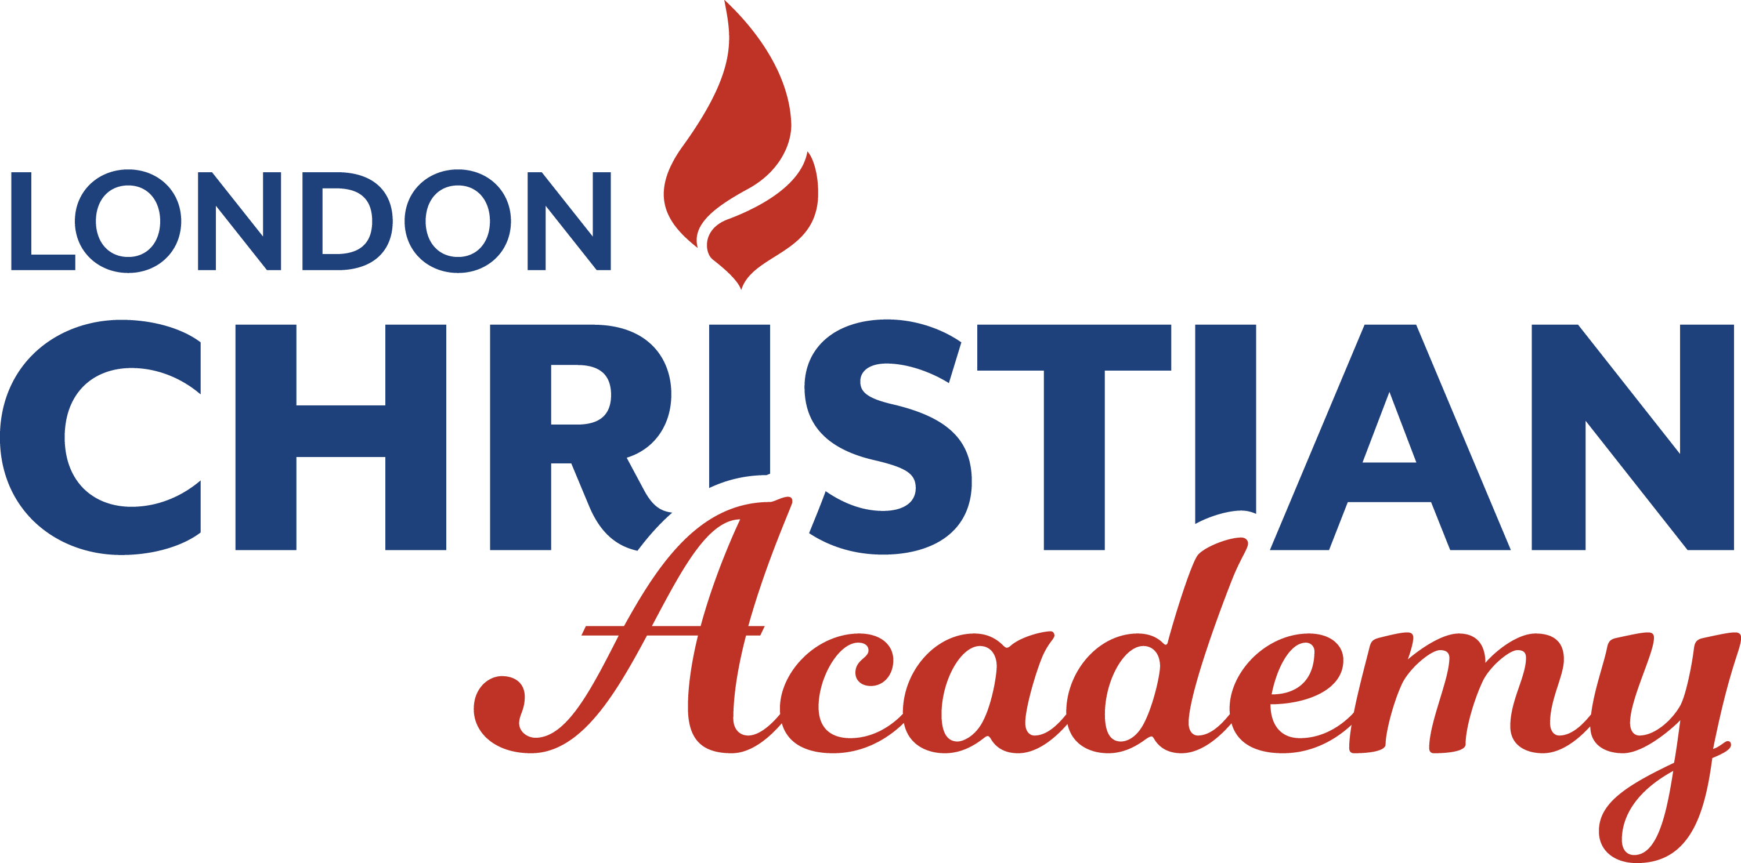
17th Annual Golf Tournament
P L E D G E A G O L F E R

Saturday, June 9th, 2018
Pledge a Golfer
You can make a donation in support of one of our golfers. Tax receipts will be issued for donations of $20 or more, only with a complete and legible mailing address.

Golfer____________________________Address_______________________
Phone___________________Email__________________________________
First Name: ___________________________Last Name:_____________________________
Address: ________________________________________City:________________________
Postal Code: ________________Phone: _________________
Cash / Check _______________Amount $_______________Receipt Required Y/N:_______

First Name: ___________________________Last Name:_____________________________
Address: ________________________________________City:________________________
Postal Code: ________________Phone: _________________
Cash / Check _______________Amount $_______________Receipt Required Y/N:_______

First Name: ___________________________Last Name:_____________________________
Address: ________________________________________City:________________________
Postal Code: ________________Phone: _________________
Cash / Check _______________Amount $_______________Receipt Required Y/N:_______

First Name: ___________________________Last Name:_____________________________
Address: ________________________________________City:________________________
Postal Code: ________________Phone: _________________
Cash / Check _______________Amount $_______________Receipt Required Y/N:_______

